Forecasting Catastrophe: Disaster Tweet Prediction Using NLP

Ravi Prasad Grandhi | Dharanidhar Manne
Department of Data Science | Department of Data Science
University of New Haven | University of New Haven
rgran8@email.com | dmann4@email.com

Abstract
By the way, information has been spreading fast in social media in recent years, and a study of how disaster-related information can be used to predict and mitigate disasters before they damage a significant number of people was necessary to be conducted. Natural Language Processing (NLP) techniques are on the front line because they efficiently deal with vast datasets. In this project, we have used BERT transformers and the PyTorch library to help quickly predict disasters while using the disaster tweets dataset, which comprises train, test, and sample submission files. The model has achieved an accuracy of 0.83 and an f1 score of 0.76. These values demonstrate that the model performed well in predicting disaster tweets.

- Introduction
In recent digital years, social media has played an essential role in distributing information in the quickest ways ever; the information disseminated by social media platforms includes disaster alerts and threats about certain natural disasters such as hurricanes. Whenever a disaster is about to happen, it only requires a single post on any social media platform, e.g., Twitter (X); this can inform a large number of people about the disaster that is about to happen. This may face challenges due to the immeasurable number of posts posted on the same platforms daily, as they may not reach people simultaneously.
The main objective of this project is to solve this problem by inducing the use of Natural Language Processing (NLP) methodologies to accurately predict disaster-related tweets from social media platforms. This is because NLP is a powerful artificial intelligence tool with much textual data. As a result, the use of NPL algorithms helps to detect disaster-alerting tweets from among the noisy dataset of media tweets. This paper, therefore, illustrates how the NLP algorithms are used to help the disaster management sectors make timely decisions on how to deal with catastrophes before damage is done.

- LITERATURE REVIEW
Several authors have previously researched predicting disaster tweets using the NPL approach.

A study by Sit et al., 2019 illustrates that they used an analytical framework to locate, examine, locate, analyze, and classify the disaster-related tweets posted before and after hurricane catastrophes. Their main objective is to collect as much information about the development of hurricanes as possible, including different phases such as preparation, response, and recovery from the catastrophe. The study was categorized into various stages. Firstly, data collection, design sampling, and collection of training and test data procedures and their classification. In the second phase, disaster-related tweets are classified into a binary format using LSTM, and the data is divided into training and test data. The paper illustrates using CNN, linear SVM, Logistic Regression, and Long Short-Term Memory (LSTM) for performance testing. The authors explain that they chose to work with LSTM after evaluating results to classify data into related and unrelated tweets. They decided both SVM to carry the baseline classifier and the Principal Component Analysis (PCA) model used for comparison. The results from different models were tested against the F1-score, accuracy, and recall to find the most appropriate model. LSTMs provided better performance results than CNN. The best achievement of this case study is that disaster-related information is obtained before, during, and after the disaster (Sit et al., 2019).

Another study by Goswami & Raychaudhuri, 2020 illustrates using Natural Language processing techniques to examine and classify tweets as "disaster-related" or "Not disaster-related." The classified dataset is used as the training and test data for the models they developed to check the accuracy of each model. They used the Decision Tree Classification algorithm to create a classifier model; this algorithm is a subset of NLP.
They collected a corpus from the millions of unstructured and unformed tweets. The dataset was preprocessed, and they conducted a series of sentiment analyses on the data, where they cleansed the data and chose to convert the whole dataset into the lower-case format. They also used Potters' stemming algorithm to analyze the converted texts. The case study illustrates that the Sparse Document Term Matrix (SDTM) is utilized to term the rarely used words in the corpus as zeros or having no meaning.
After thoroughly testing the models, the accuracy was calculated using the Area under Curve (AUC) score, a graphical computation. This tests the accuracy of the models that could help predict disasters in real time and help succumb to them before they attack.
The main shortcoming of this case study is that the corpus cannot be reduced to a certain level, as this will cause a decrease in the performance of the proposed models by 0.5 % - 1% (Goswami & Raychaudhuri, 2020).

- RESEARCH METHODOLOGY
This section covers the technical implementation of the project. It covers all the necessary steps to ensure a robust model for disaster tweet predictions.
  - Dataset
The dataset used in this project is from the Kaggle competition. It is divided into two files (train – the training set, test – the test set, and sample_submission.csv - a sample submission file in the correct format). Below are the features in the dataset.
- id - a unique identifier for each tweet
- text - the text of the tweet
- location - the location the tweet was sent from (may be blank)
- keyword - a particular keyword from the tweet (may be blank)
- target - in train.csv only, this denotes whether a tweet is about a real disaster (1) or not (0)

3.2 Data Cleaning
Tweet data might contain unwanted text elements such as URLs, emojis, HTML tags, and punctuations that are unnecessary and optional for analysis as they would affect the performance of the models. In addition, the dataset also goes through various NLP processing techniques such as tokenization, stopwords removal, lemmatization, and standard text transformation processes such as lowercasing. All these techniques ensure that the final texts to be analyzed are in the correct format. This process also involves applying some speech tags. The resulting data frame (first five records) is shown in the figure below.

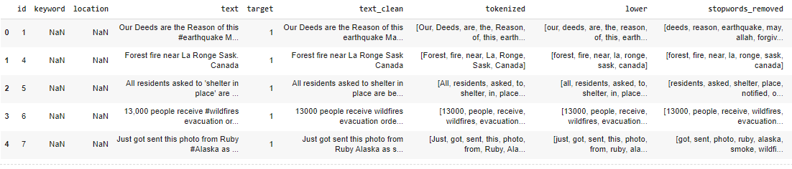
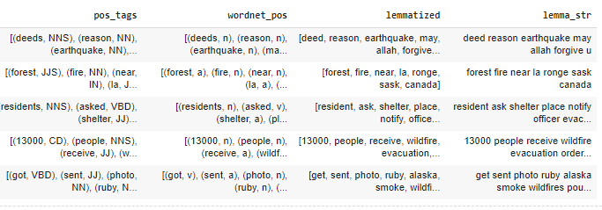
Figure 1: A preview of the data

At this point, the text is clean and ready for further analysis and insights.

3.3 Data Visualization
Data visualization helps us understand the data better by generating visuals that tell us more about the data.

3.3.1 Target Distribution
The first visualization we would like to create shows the distribution of our target variable. This is shown in the figure below.
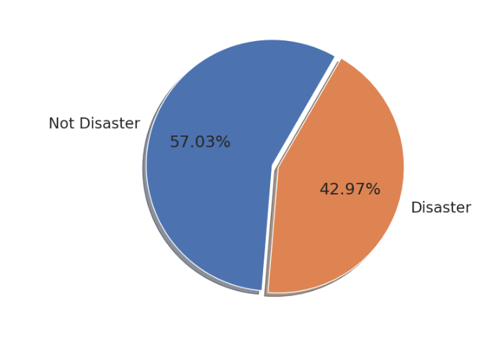
Figure 2: Target Distribution

From the figure above, the dataset is balanced, with 57% being non-disaster tweets and the remaining tweets being disaster tweets.

3.3.2 Word Counts Visualization
It is essential to know the distribution of word counts per tweet type. These visualizations are shown in the two figures below.
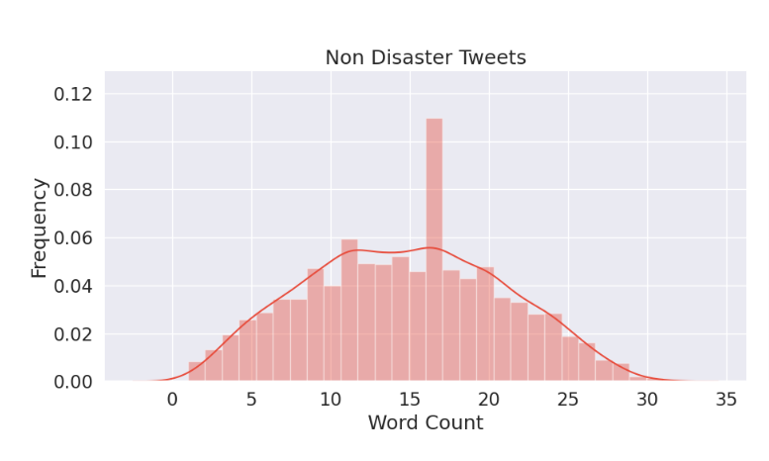
Figure 3: Word Count Visualization Non-Disaster Tweets
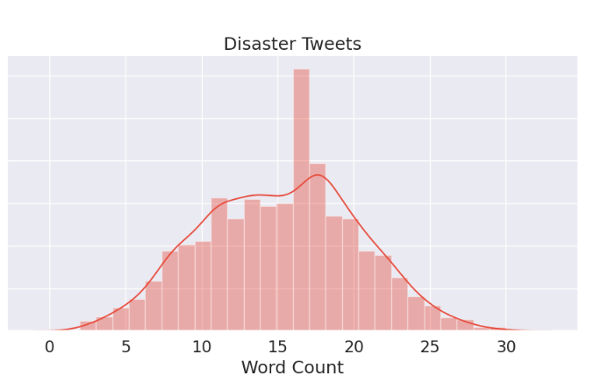
Figure 4: Word Count Visualization Disaster Tweets

Disaster tweets have longer words than non-disaster tweets, which is a good sign.

3.3.3 Most Common Words
In addition to analyzing the quantitative features of the tweets, it is also essential to examine the words themselves. We first start with the most common words in both classes.
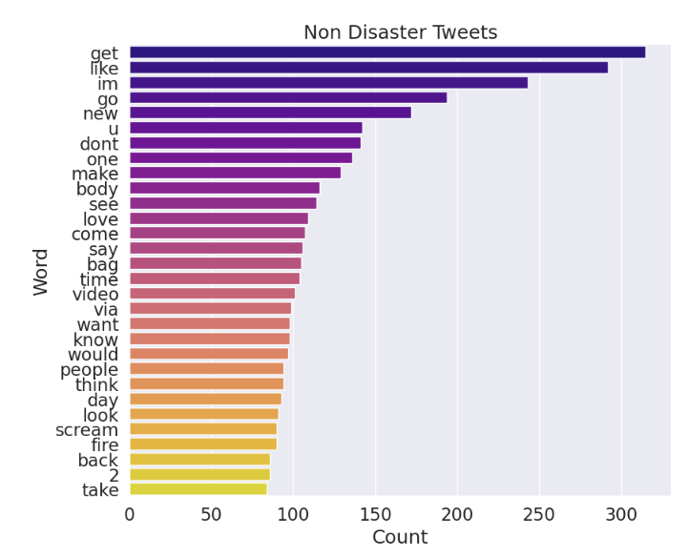
Figure 5: Most Common Words Non-Disaster Tweets

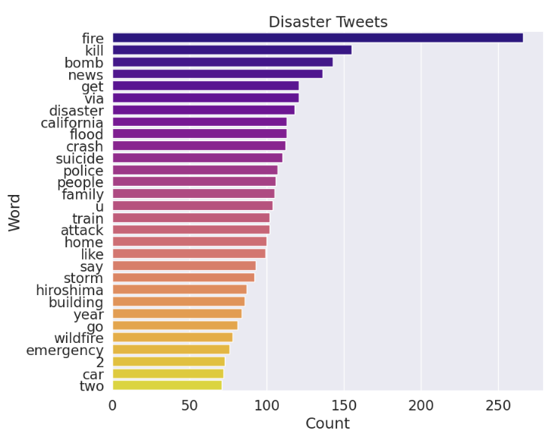
Figure 6: Most Common Words Disaster

The two plots above show that disaster tweets have words like fire, kill, bomb, flood, crash, storm, etc. These are words associated with disasters.

3.4 Model Building
We will build our model using BERT with the help of Transformers. The initial step is to tokenize and format the input data. This process outputs tokenized data and token IDs, which are helpful for the model.

Figure 7: Sample tokenized text

The dataset is split into train and validation sets by randomly selecting samples.
The architecture of the BERT model is shown in the figure below.
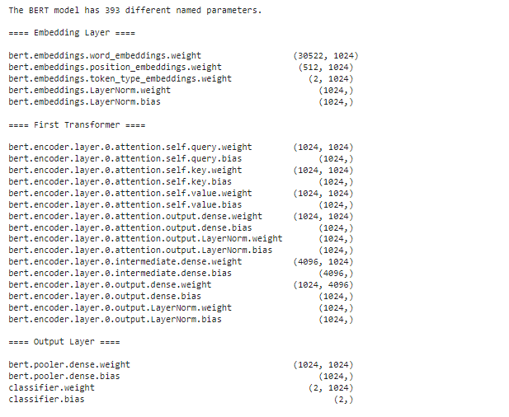
Figure 8: BERT model architecture

3.4.1 Setting the Bert Classification Model
This project leverages bert-large-uncased from Hugging Face to get more accurate results. BertForSequenceClassification is a pre-trained BERT model with a single linear classification layer. Is loaded.

The figure below shows the overall summary of epoch training.

3.4.2 Predictions and Submission
After the model has been tested on train data, we then evaluate the model using the test data to make predictions.

- RESULTS AND ANALYSIS
This section discusses the results obtained from the training and evaluation of the BERT model for disaster tweet prediction.
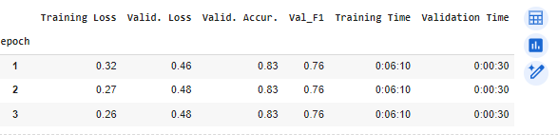
Figure 9: Model training and evaluation results table

From the figure above, the BERT model achieved an F1 score of 0.76 and an accuracy of 0.83 during evaluation despite a validation loss of 0.52. The accuracy of 0.83 indicates that the model accurately identified whether tweets were related to disasters 83% of the time. The F1 score, which balances precision and recall, of 0.76 suggests that the model indicates a reasonable balance between the accuracy of optimistic predictions and the rate at which it captures real positive cases.

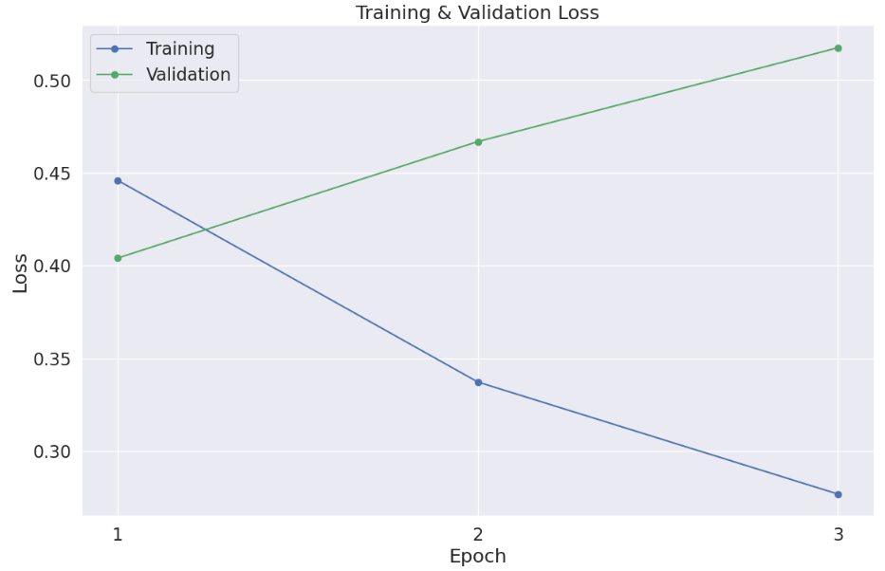
Figure 10: Training and Validation Loss Plot

The BERT model shows a decreasing trend in training loss across three epochs, indicating it is effectively learning to predict disaster-related tweets from the training data. However, the validation loss remains consistently higher than the training loss. It does not show a similar downward trend, suggesting the model must generalize well to the unseen validation data.

- CONCLUSION
In conclusion, this case study utilized various Natural Language Processing (NLP) algorithms on social media tweets to predict multiple disasters. Using BERT with transformers as a model for tweet classification is an essential part of this project. Also, the utilization of Pytorch, a Python library, has helped classify the vast dataset from tweets while also training the data to indicate whether it is disaster-related.
We used a pre-trained BERT model (bert-base-uncased) and achieved an accuracy of 0.83 and an f1 score of 0.76. This illustrates that the model performed well in predicting disaster tweets.

References
Goswami, S., & Raychaudhuri, D. (2020, May 26). Identification of Disaster-Related Tweets Using Natural Language Processing: International Conference on Recent Trends in Artificial Intelligence, IOT, Smart Cities & Applications (ICAISC-2020). Papers.ssrn.com. https://papers.ssrn.com/sol3/papers.cfm?abstract_id=3610676
Sit, M. A., Koylu, C., & Demir, I. (2019). Identifying disaster-related tweets and their semantic, spatial and temporal context using deep learning, natural language processing, and spatial analysis: a case study of Hurricane Irma. International Journal of Digital Earth, 12(11), 1205–1229. https://doi.org/10.1080/17538947.2018.1563219

